

DYNAMICS TMS

Objectives:
- How to Add Carrier Contract /Tariff

Introduction:
This document assists in carrier contract set up and tariff loading.

How to Add Carrier Contract/Tariff

This is only for carriers that use the TMS tariff engine. API carriers are not required to have a contract. See support for more information on your specific configuration and if API’s are supported.

1) Go to Contracts
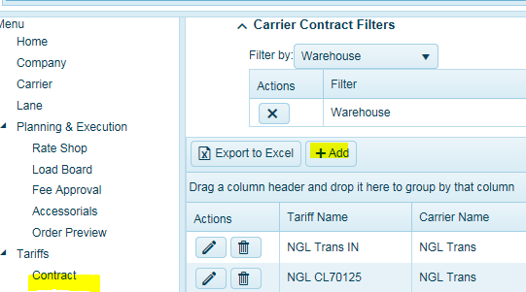
2) Click on Add

3) Fill in the fields
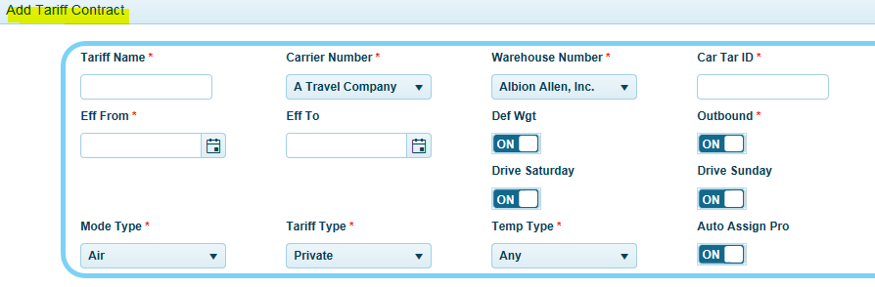
  - Contract/Tariff Name (Examples: RidgeWay - TL , Swift – Intermodal, FedEX – LTL Economy
  - Select Carrier
  - Select warehouse location
  - Contract ID (Example: Contract number or other unique naming convention)
  - Effective Date From-when the new contract begins (load date).
  - Effective Date To - when the contract ends (not required)
  - Def Weight - Check on if this tariff requires deficit weight (LTL) calculations.
  - Direction = Outbound – select ON, Inbound select OFF.
  - Drive Sat, Sun (typically applied to truckload shipments-ON)
  - Mode - Note: Modes available are Road, Rail, Air, Sea, Service Note: Intermodal = Rail
  - Tariff Type (Private = negotiated contracts, Public = public contracts)
  - Temp – Dry, Frozen, Cooler, Any (must match equipment being used for this contract)
  - Auto Assign PRO Number ON/OFF (used with auto carrier assign Pro Number generation)
  - Click Save
4) Now apply the Service/Equipment associated with this Contract/Tariff.
a. Highlight the contract you just created and select Service in the Actions menu.
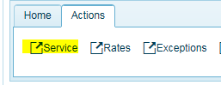

5) Select the Service
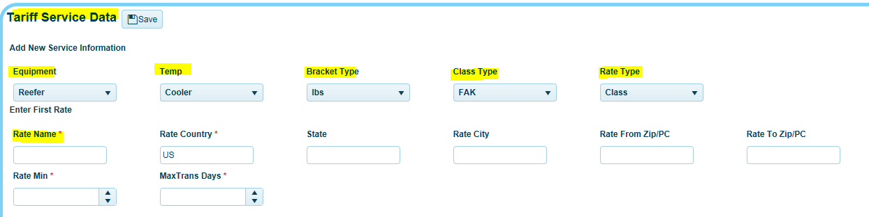
a. Select service/equipment based on your configuration (LTL, Truckload, B Train)
b. Temperature (will auto populate based on default equipment selection)
c. Bracket type for contract (LBS, Pallet, Cases, Cubes)
d. Class Type (typically FAK)
e. Rate Type
i. Class for LTL
ii. Distance for rate per mile
iii. Flat for flat rate
iv. Unit of Measure for Pallet
f. Insert a Rate Name i.e. LTL FAK 70 Or TL Distance (truckload) (any name)
g. Insert Rate Min-This will create the first row of the tariff, so importing rate files can take place.
h. Click Save (You do not need to populate the rest at this time)
6) Import Rates-go to the desktop client under the Systems Tab and click on Tariff Import Tool.
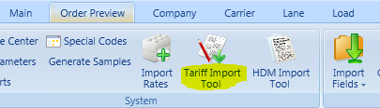

7) The tariff import management screen will open.
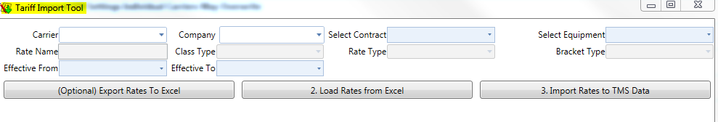
a. Select Carrier
b. Select warehouse company location
c. Select Contract (Select the most recent contract (revision number will display) you wish to
update. (Note, the bottom one is the most recent and will display Tariff Name and Car Tar ID)
d. Select equipment
e. Insert Effective Date
Once you have selected the equipment, the system will auto-fill the tariff types your looking to work with and auto insert the Rate Name, Class Type, Rate Type, and Bracket Type.
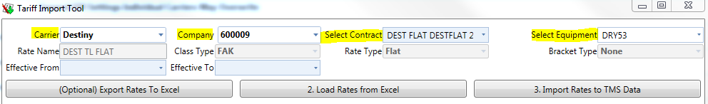
8) Click #2 Load Rates from Excel - The file should be accessible in a shared folder or drive. After you click the button, the system will open a file folder menu for you to select the tariff file you want to import. Select the file and click Open.
9) The system will insert the rates from the tariff template in the preview screen.
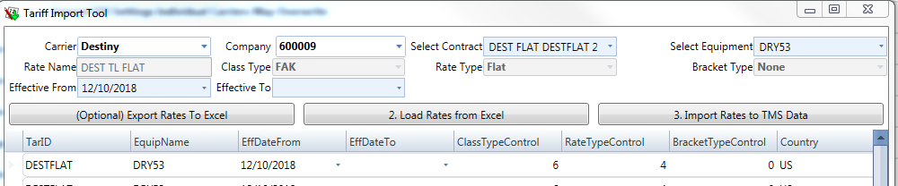
10) Then click on #3. Import Rates to TMS Data. Once it is complete, it will show a success message with the number of records imported.
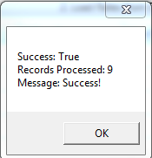
If importing an LTL tariff, you will need to complete the configuration for the Exceptions, Discounts, and Minimum Charges if applicable.
Always check your weight breaks for carrier LTL weight brackets. When reviewing the rates, click and highlight a row of rates and then click on Break Points in the Actions bar to edit and insert the brackets.
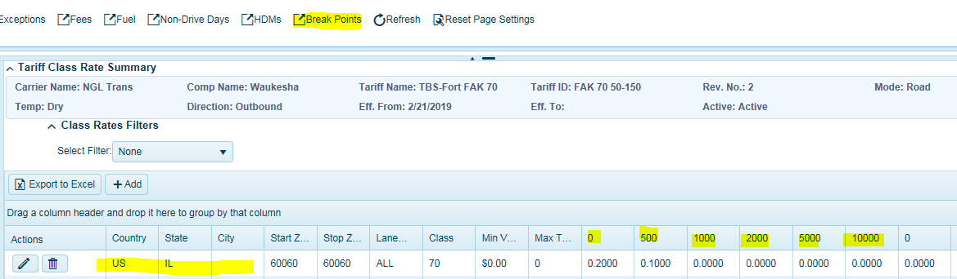

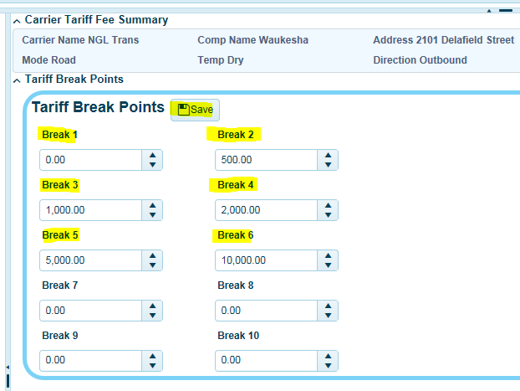
Click Save when done.
Be sure to configure carrier fuel matrix and assign fees/stop charges to the contract as necessary.
See Tariff Documentation around additional configuration for LTL tariff exceptions.

